|  |  |  |  |  |
| --- | --- | --- | --- | --- |
| Name: Nishchal Sreevathsa |  |  |  |  |

Attacking Web Servers from the WAN

Ethical Hacking & Lab 9

Table of Contents

1. Executive Summary 2

Highlights

Objectives

1. Lab Description Details 3

Include Steps Taken, Notes, & Screen Shots demonstrating completion of lab objectives

1. Supporting Evidence 14
2. Conclusion & Wrap-Up 16

Summary with observations, Success & Failures, Challenges

# Executive Summary

## Highlights

|  |  |
| --- | --- |
|  | During this lab, you will use a Kali Linux attack machine to launch a wide area network (WAN) attack on a web server. The intention is to use vulnerabilities to obtain unauthorized access to the web server.  The parts of the lab are as follows:   * Reconnaissance: Identification of open ports and services on the firewall guarding the web server is done through the use of nmap or Zenmap to search the network. * Exploitation: To get the administrator password, use Bruter to launch a brute force dictionary attack against SMTP on port 25. * Obtaining Access: To remotely connect to the web server, use RDP and the compromised admin credentials. * Preserving Access: Alter index.html on the web server to vandalize the website. * Covering Tracks: To erase all evidence of the assault, delete the relevant log entries from access.log. After defacing the website, stop and restart the Apache web server.   The lab shows how to utilize technologies like nmap, Bruter, RDP, etc. to attack and exploit a web server from the WAN. Students gain knowledge about how intruders might evade detection, continue to be persistent, and obtain illegal access. |

## Objectives

|  |  |
| --- | --- |
|  | Recognize how to attack from both WAN and LAN viewpoints. A threat from the outside is someone attacking over the WAN.  To find active hosts, open ports, services, and operating systems, use nmap for reconnaissance.  Use wordlists and dictionaries in brute force attacks to break passwords.  Acquire perseverance and keep access with hacked credentials.  Use input validation flaws and lenient file permissions to alter or deface websites.  To hide evidence of an assault, destroy logs, event records, files, etc.  Use proxies or VPNs, hide files, turn off logging, and other techniques to avoid discovery.  Change course and launch an additional network attack from a compromised server.  Use Metasploit to create exploits and attacks more quickly.  Recognize the legal ramifications of breaking into systems without authorization.  Discover the tools, strategies, and processes that penetration testers and ethical hackers employ. |

# Lab Description Details

## Include Steps Taken, Notes, & Screen Shots demonstrating completion of lab objectives

**Launching the Attack**

**Step 1:** From the mentioned topology launch the Windows 8.1 Attack Machine with the external IP Address **175.45.176.200**. In command prompt we search for open ports in the firewall for campus network using **nmap**.

Command: **nmap** [**www.campus.edu**](http://www.campus.edu)

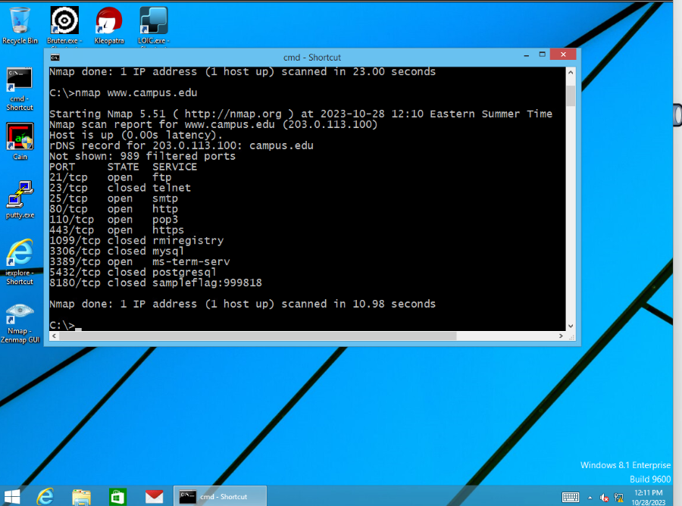

Captured the **Sample flag:999818** for TCP port with number **8180**.

**Step 2:** **Zenmap** Application is then opened from the command prompt using the command: **zenmap**. Once after the application gets opened enter [**www.campus.edu**](http://www.campus.edu) in the Target field and select the scan button to perform the intense scan. After several minutes the number of open ports will be displayed in **Ports/Host Tab**. Then close the zenmap without saving.

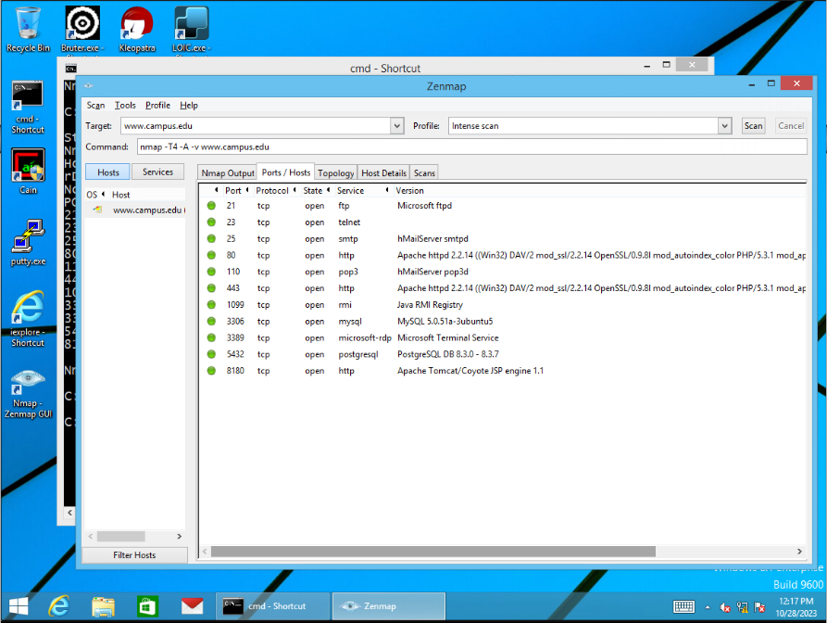

**Step 3:** Launch the Bruter.exe application, and enter [**www.campus.edu**](http://www.campus.edu) in the target field, Simple Mail Transfer Protocol(**SMTP**) is being exploited here which has the port number **25.** Next to SMTP protocol select the Option button and SMTP option window gets opened and in that select **LOGIN** as Authen Method and enter domain as **campus.edu** and press the **OK** button.

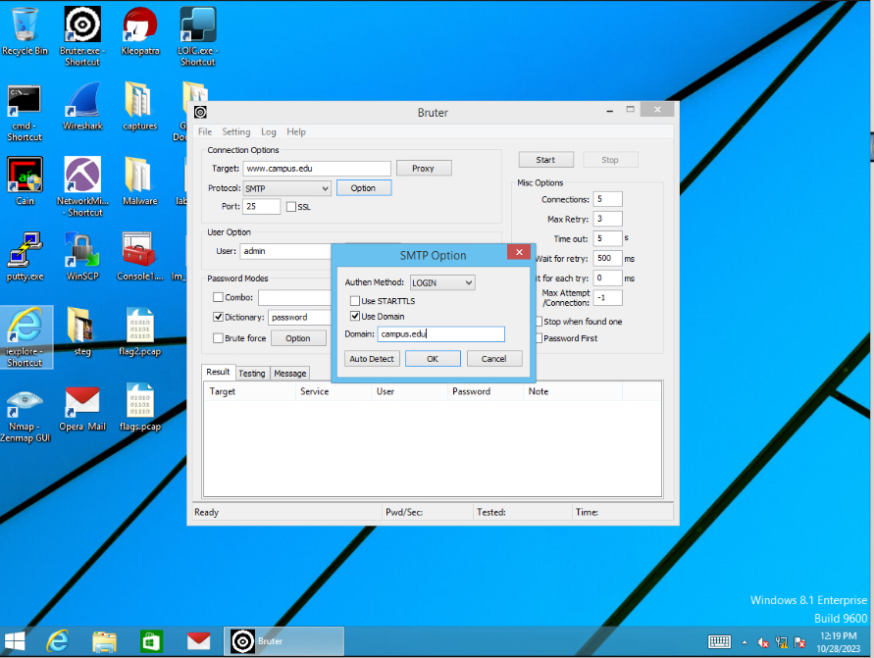

In the user option type **administrator** as the User and then click on browse next to Dictionary and select the **Wordlist.txt** file and then press the **Start** button to launch the attack to get the list of commonly used passwords.

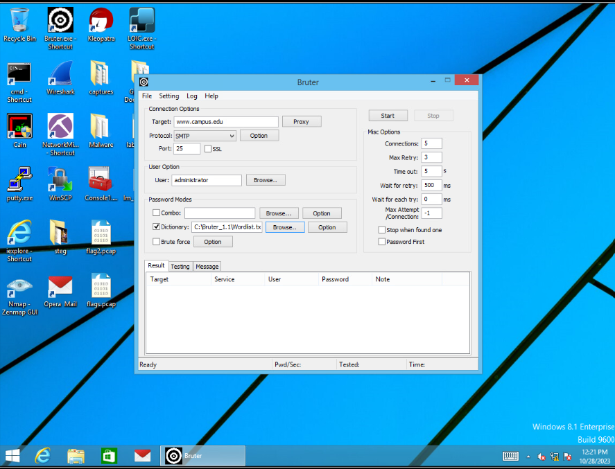

Go to **Testing Tab** in Bruter.exe Application to view the Bruter Cycle which is scanning the Dictionary text file.

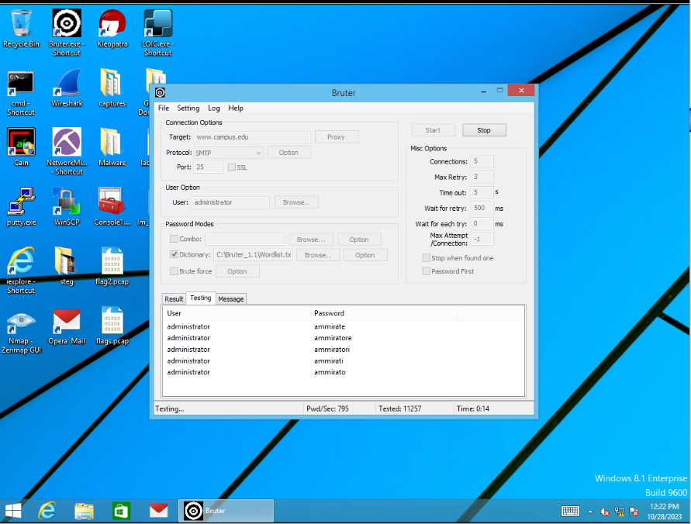

It takes several minutes for the attack to finish and once the attack is finished the passwords would be retrieved and showed in **Result tab**. Here for the target [**www.campus.edu**](http://www.campus.edu) with the user as **administrator** the password is **P@ssw0rd.**

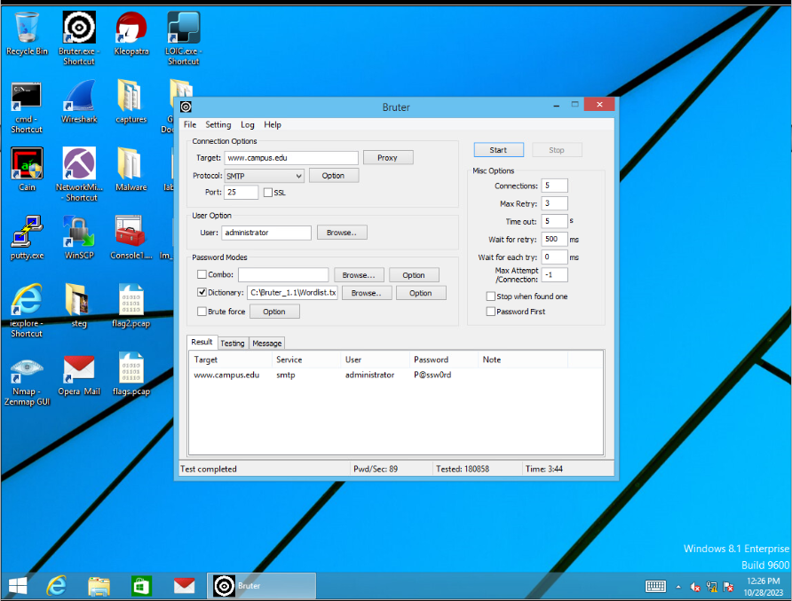

**Challenge 1:** Performed the Similar attack with SMTP protocol with port number 25 for the user **flag2** and captured the password for flag2 user and **flag2 number: 123459.**

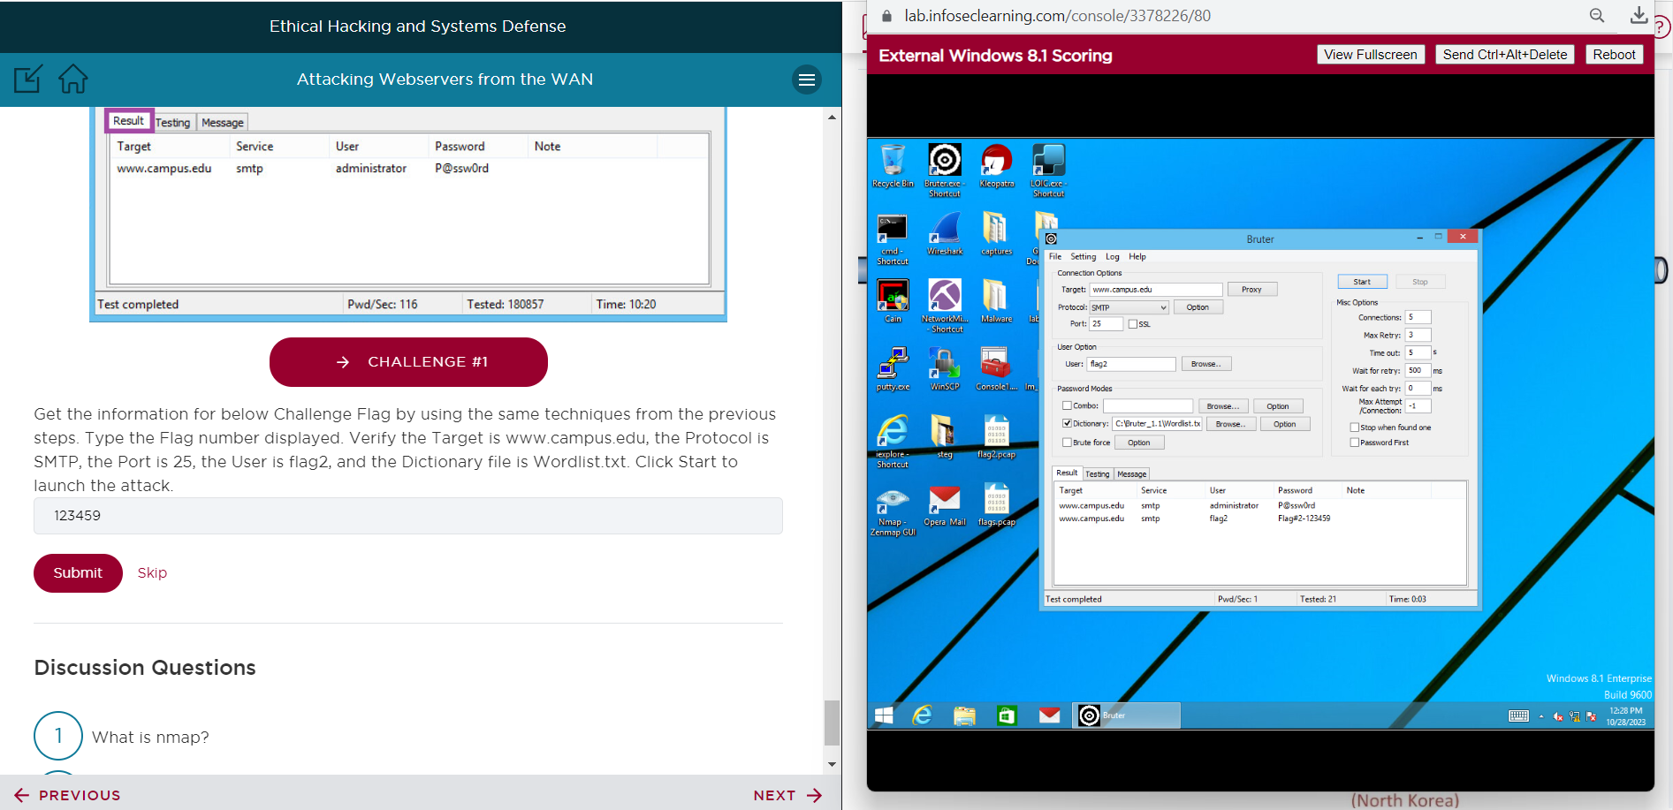

**Altering the Website**

**Step 4:** Launch the **Internet Explorer** and type the URL as [**http://www.campus.edu**](http://www.campus.edu) and go to this website which displays as **Windows 2008 Internal Server**.

**Challenge 2:** To find the **flag3**: type the URL as [**http://www.campus.edu/flag3.txt**](http://www.campus.edu/flag3.txt)**,** Flag 3 number is displayed on the Website (**flag3: 776551**).

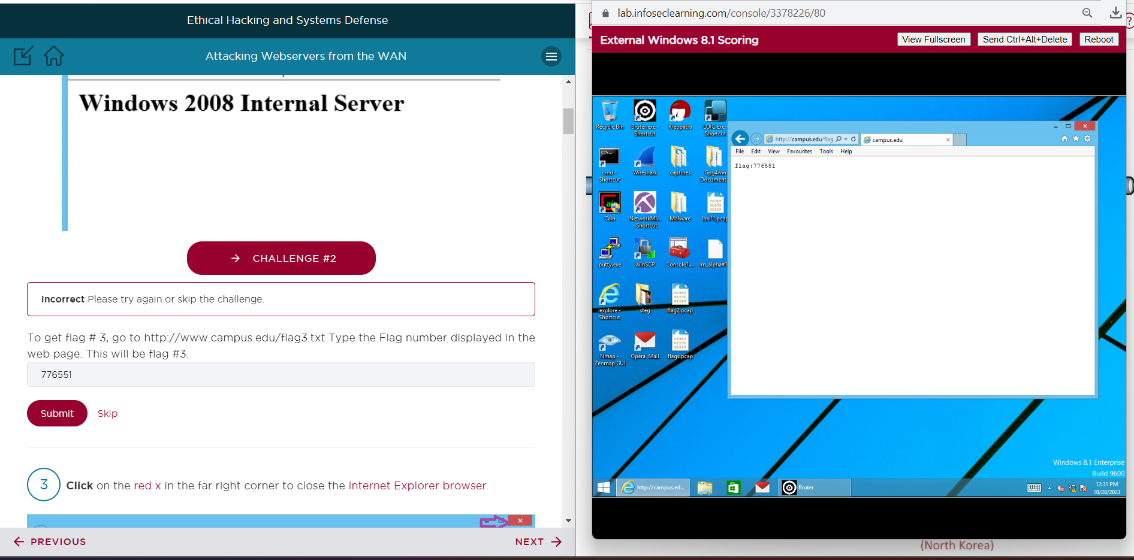

**Step 5:** Find whether Remote Desktop Protocol (RDP) is opened on the firewall with **port number 3389**.

Command: **nmap** [**www.campus.edu**](http://www.campus.edu) **-p 3389**

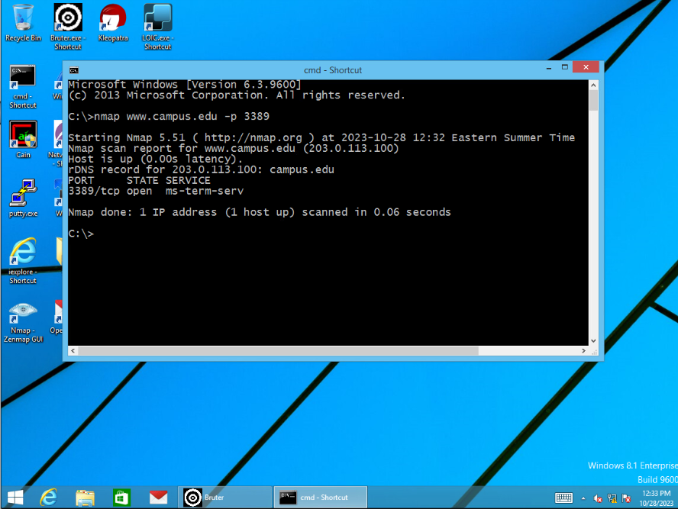

**Step 6:** Open the Microsoft Terminal Service Client using the command **mstsc**, In the Remote Desktop Connection Window enter [**www.campus.edu**](http://www.campus.edu) for the computer field and the press the **Connect** button. Enter the Username as **administrator** and Password as **P@ssw0rd** and press the **OK** button. RDP connection would be established and remote Windows 2008 Server desktop will be displayed on the screen.

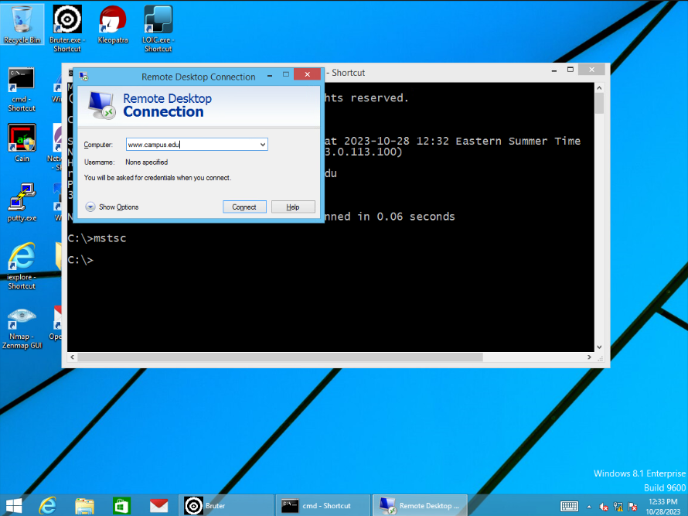

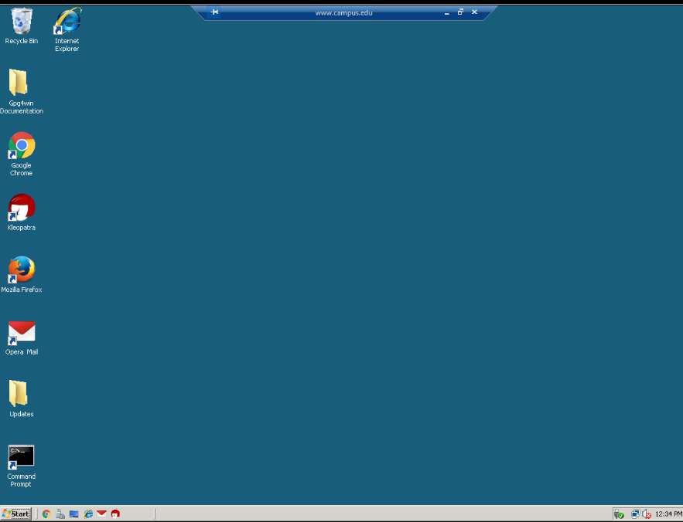

**Step 7:** In the Remote Desktop go to **Local Disk (C): drive** and then select **xampp** folder and open the **htdocs** folder and then open the **index.html** in the **Notepad**.

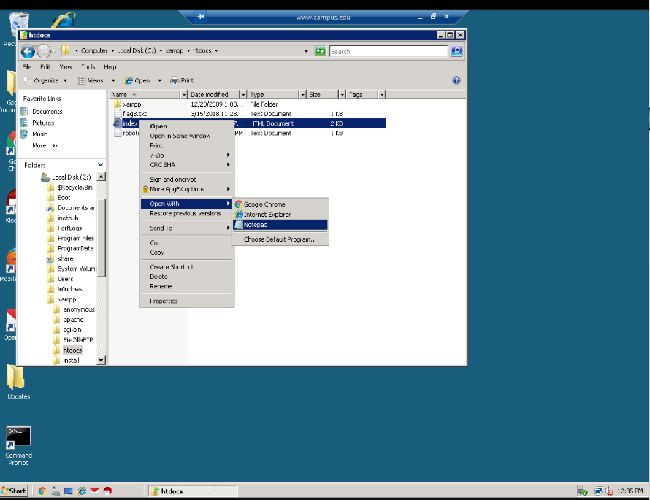

Then change the text in the notepad from **Windows Internal Server** to **Hacked Web Server** and the save file and exit the file.

**Challenge 3:** At the last line of the index.html file, **flag 4** is found, captured the **flag4: 343556**.

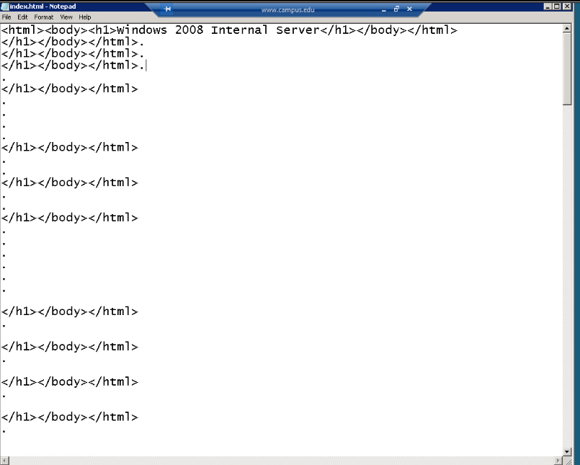

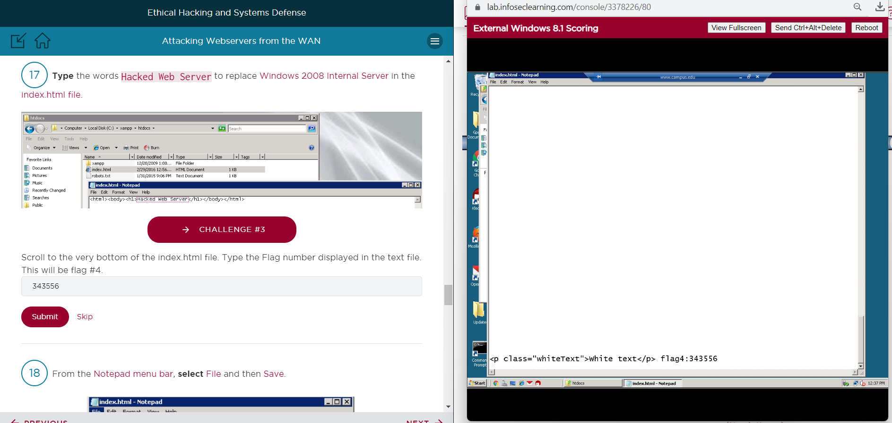

**Step 8:** Open the Internet Explorer by minimizing the remote Windows desktop and now type the URL: [**http://www.campus.edu**](http://www.campus.edu) which displays the message as **Hacked Web Server**.

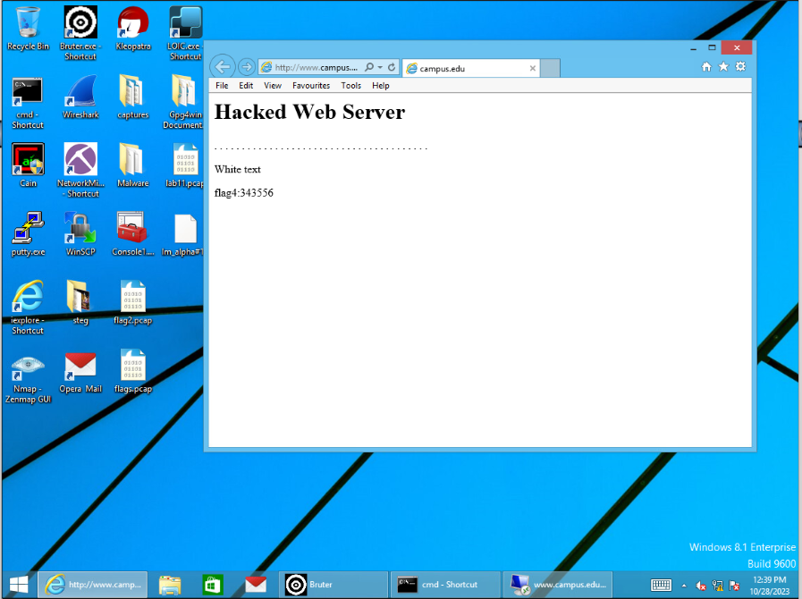

**Clearing the Tracks**

**Step 9:** Maximize the RDP Window and open the Command prompt on Windows Server 2008 Desktop and **end** the **Apache Web Service**. Command: **net stop Apache2.2**.

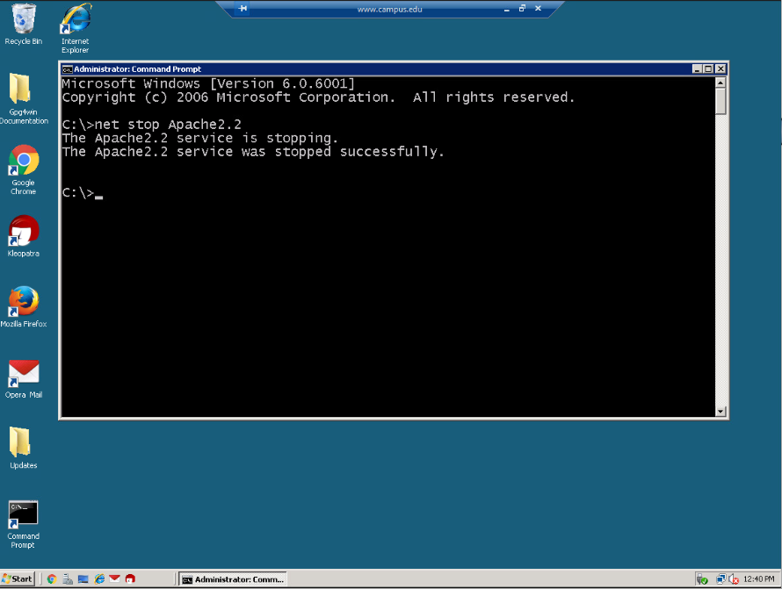

**Step 10:** Once the Apache Service is ended, **clear the logs** recorded from it. Got to **Local Disk (C):drive** then open the **xampp** **folder** and then open the **apache folder** and then open the **logs folder** and select the **access.log file.**

**Challenge 4:** Opened the **flag5.txt** file inside the logs folder and **captured the** **flag5: 818772**.

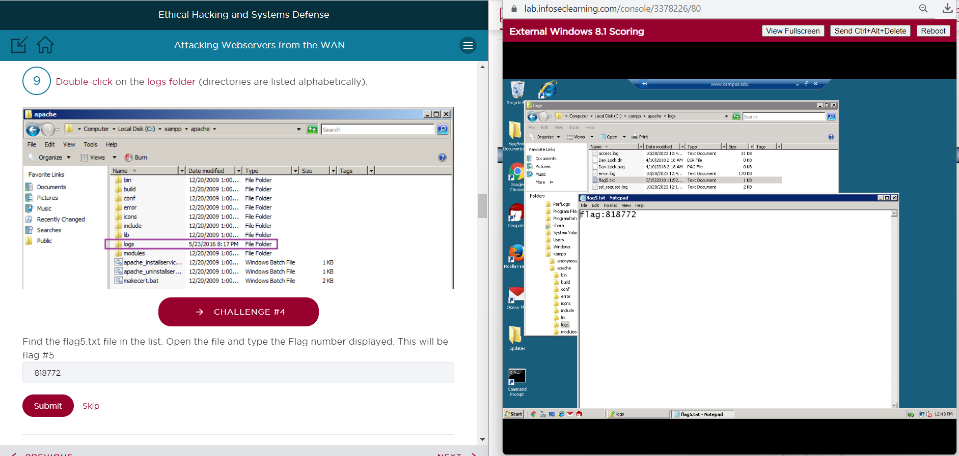

**Step 11:** In the **access.log file** search for the log entries with **IP Address 175.45.176.200** and **select all** those entries that **begins** with **175.45.176.200** and **delete all those entries** from the Notepad and then save the file and then exit the file.

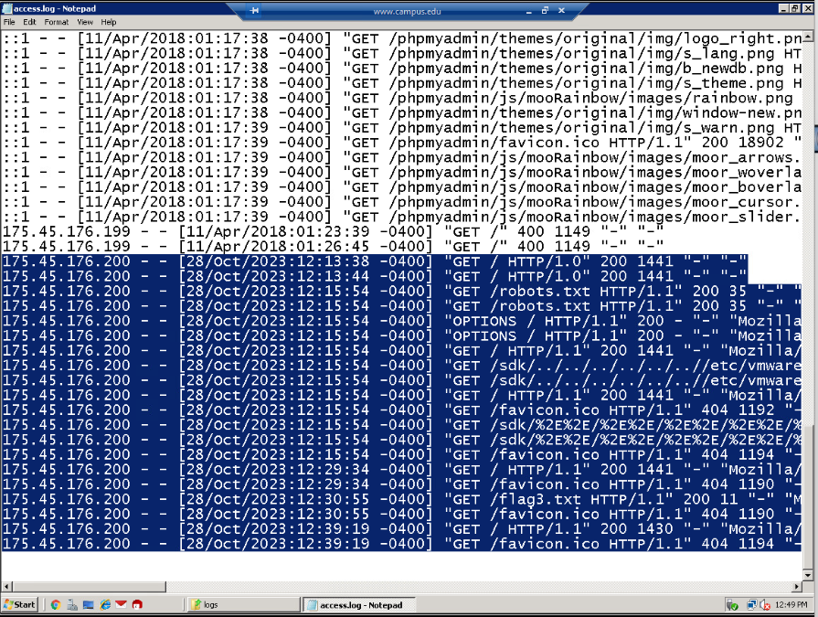

**Challenge 5: Captured the flag6: 445616** in the **access.log file**.

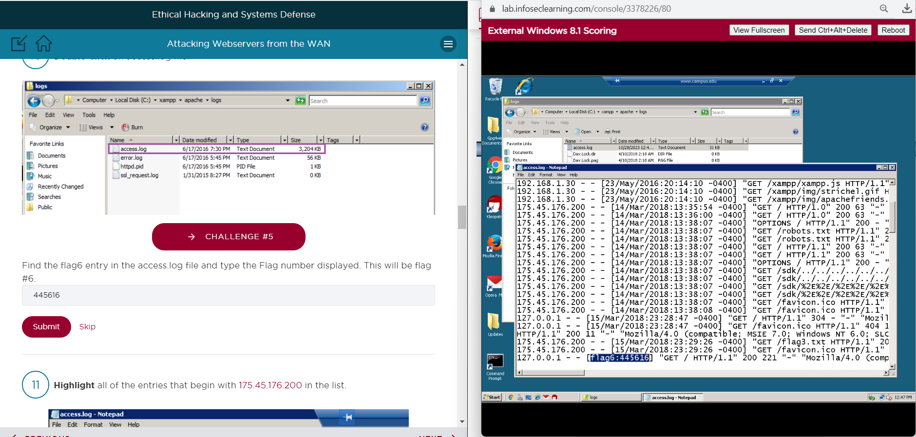

**Step 12:** After successfully deleting all the log entries from the access.log file, **Start the Apache Web Service** again using the command: **net start Apache2.2** and then exit the command prompt.

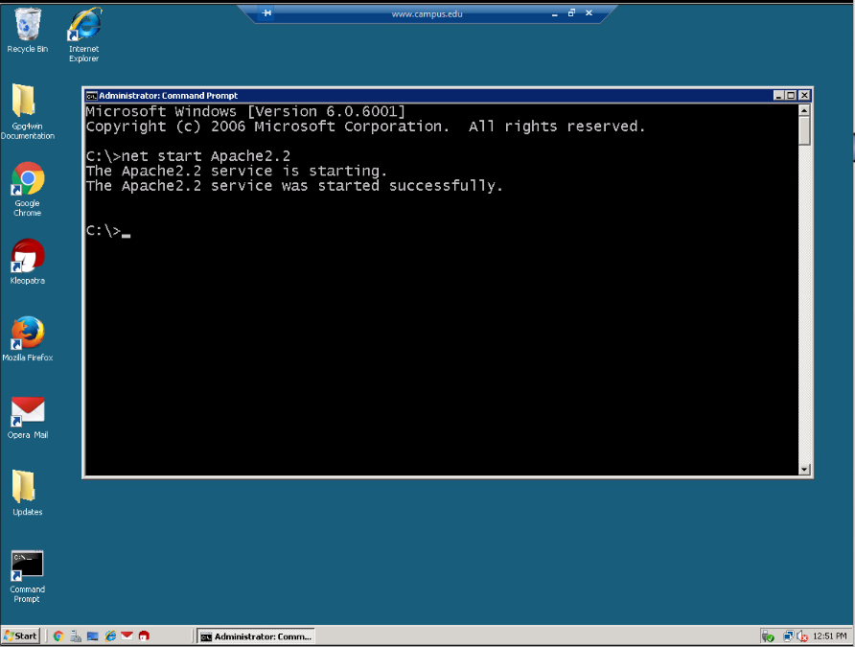

**Step 13:** Open the **Mozilla Firefox** application and type the IP Address **127.0.0.1** in the URL bar to check whether the website is Up and running which displays the message as **Hacked Web Server**. Then Log off from the system.

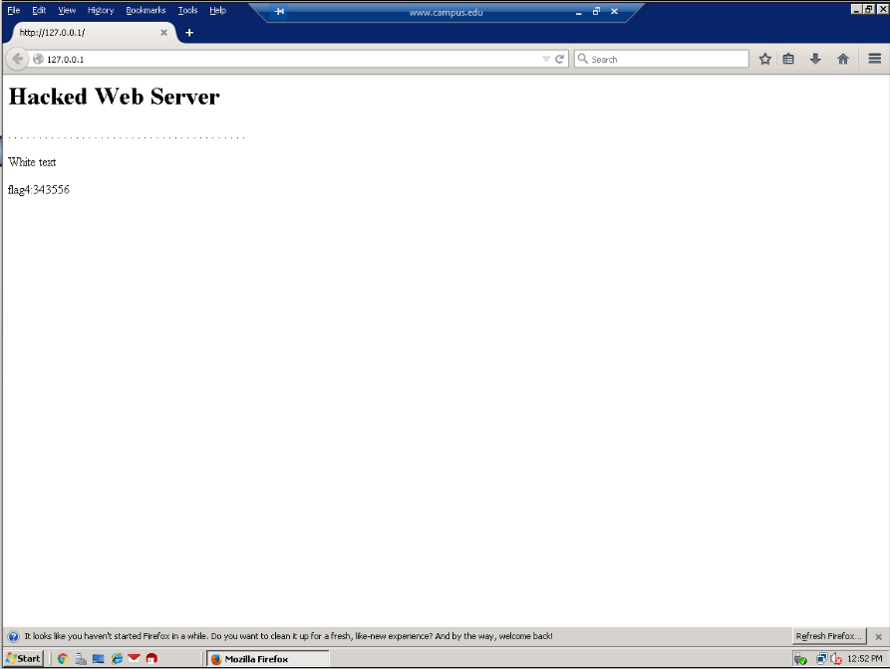

# Supporting Evidence

**Screenshots, Research, Etc.**

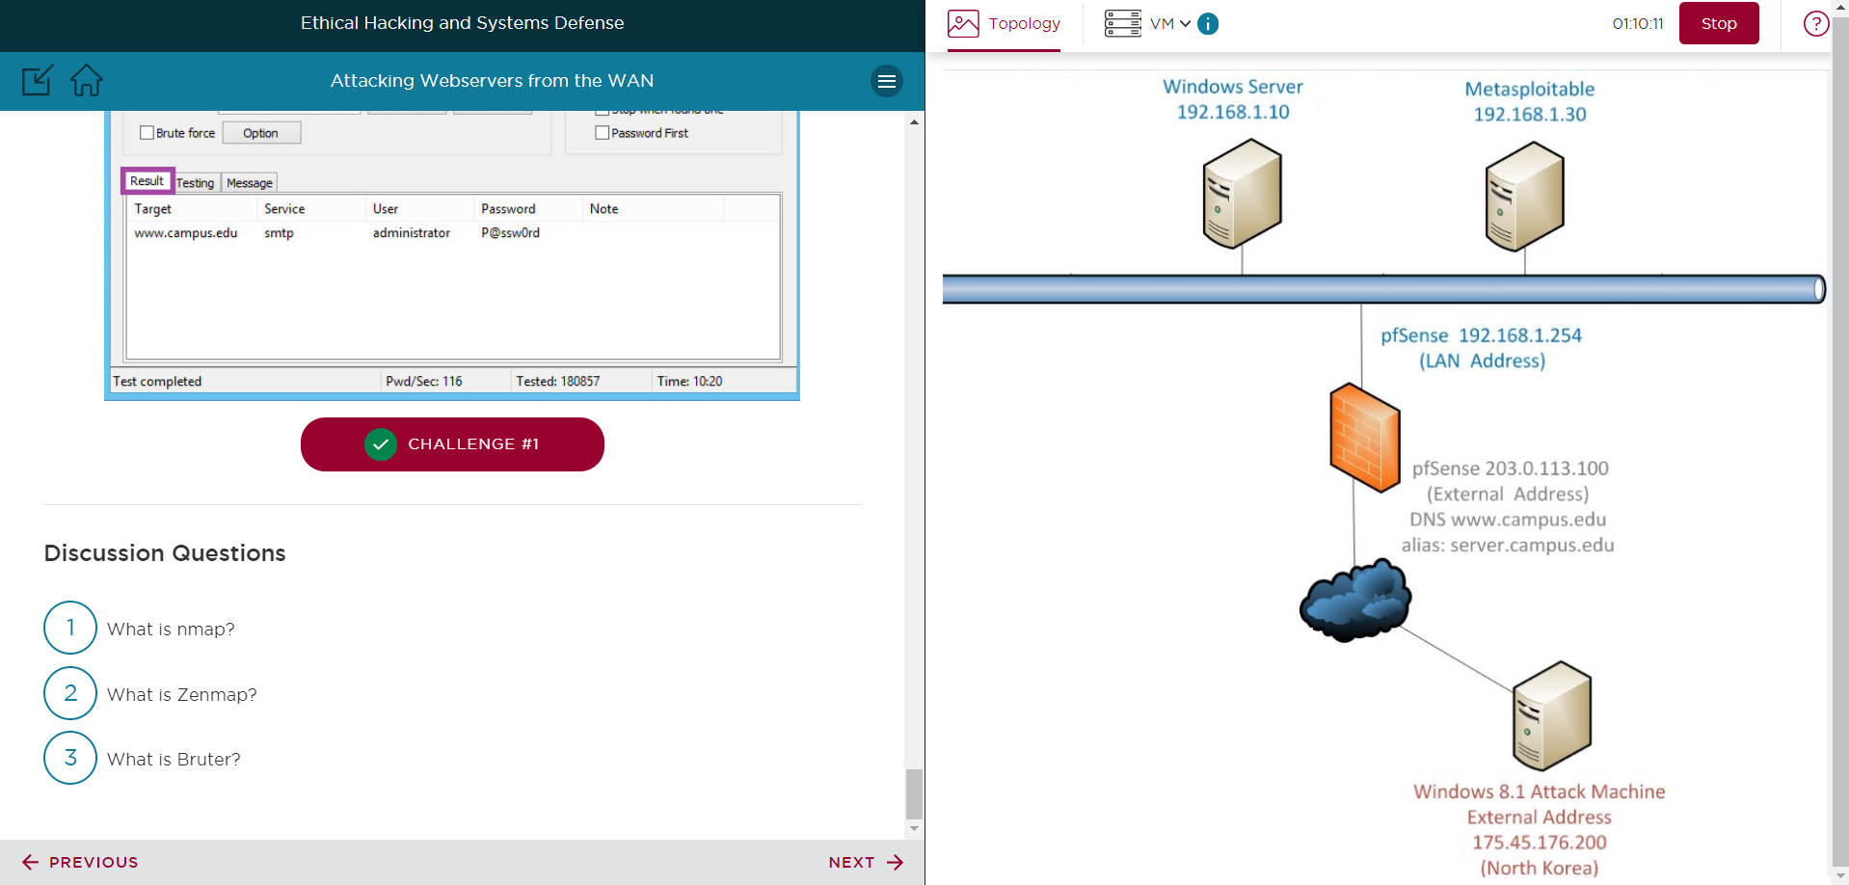

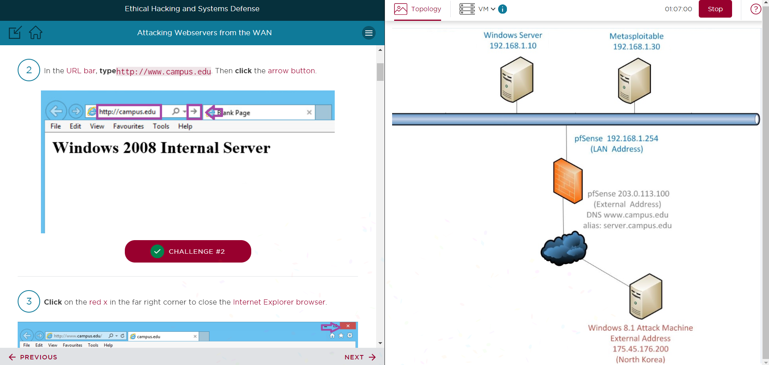

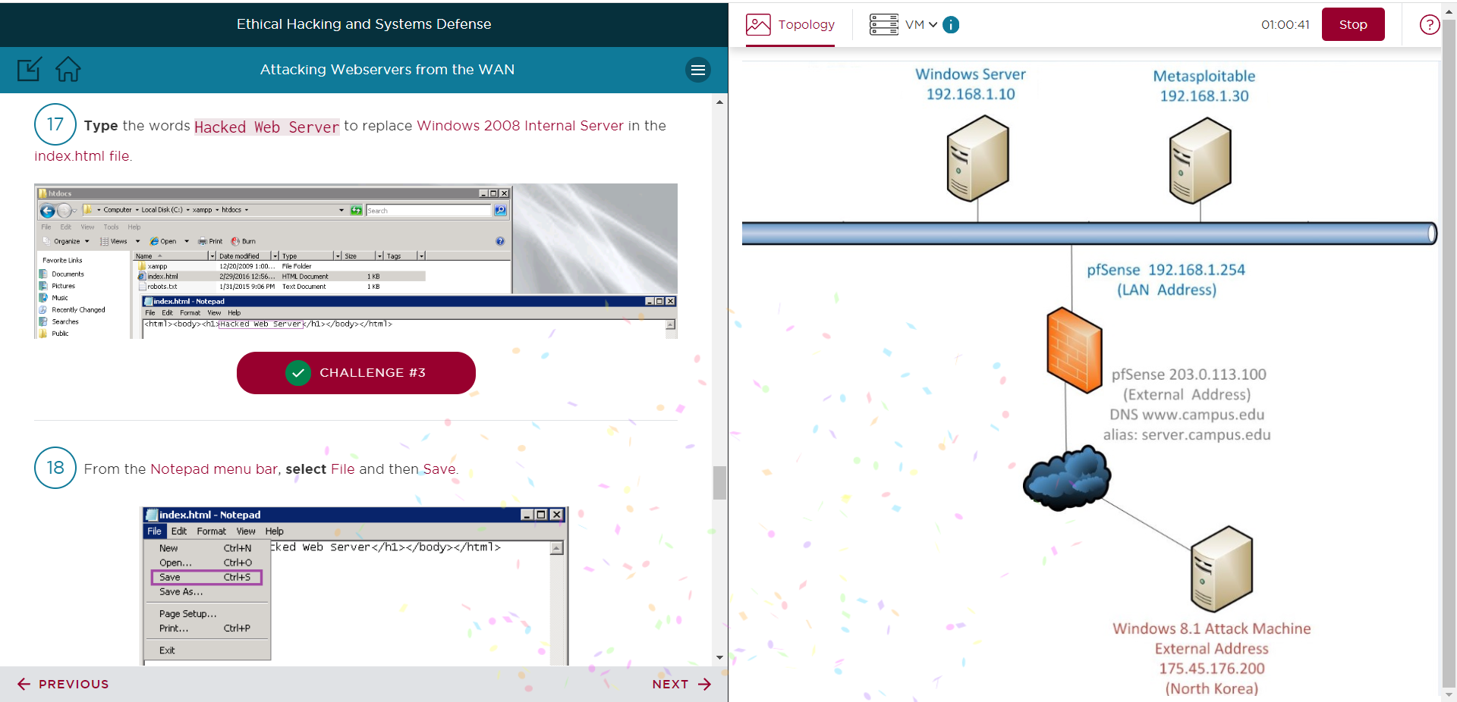

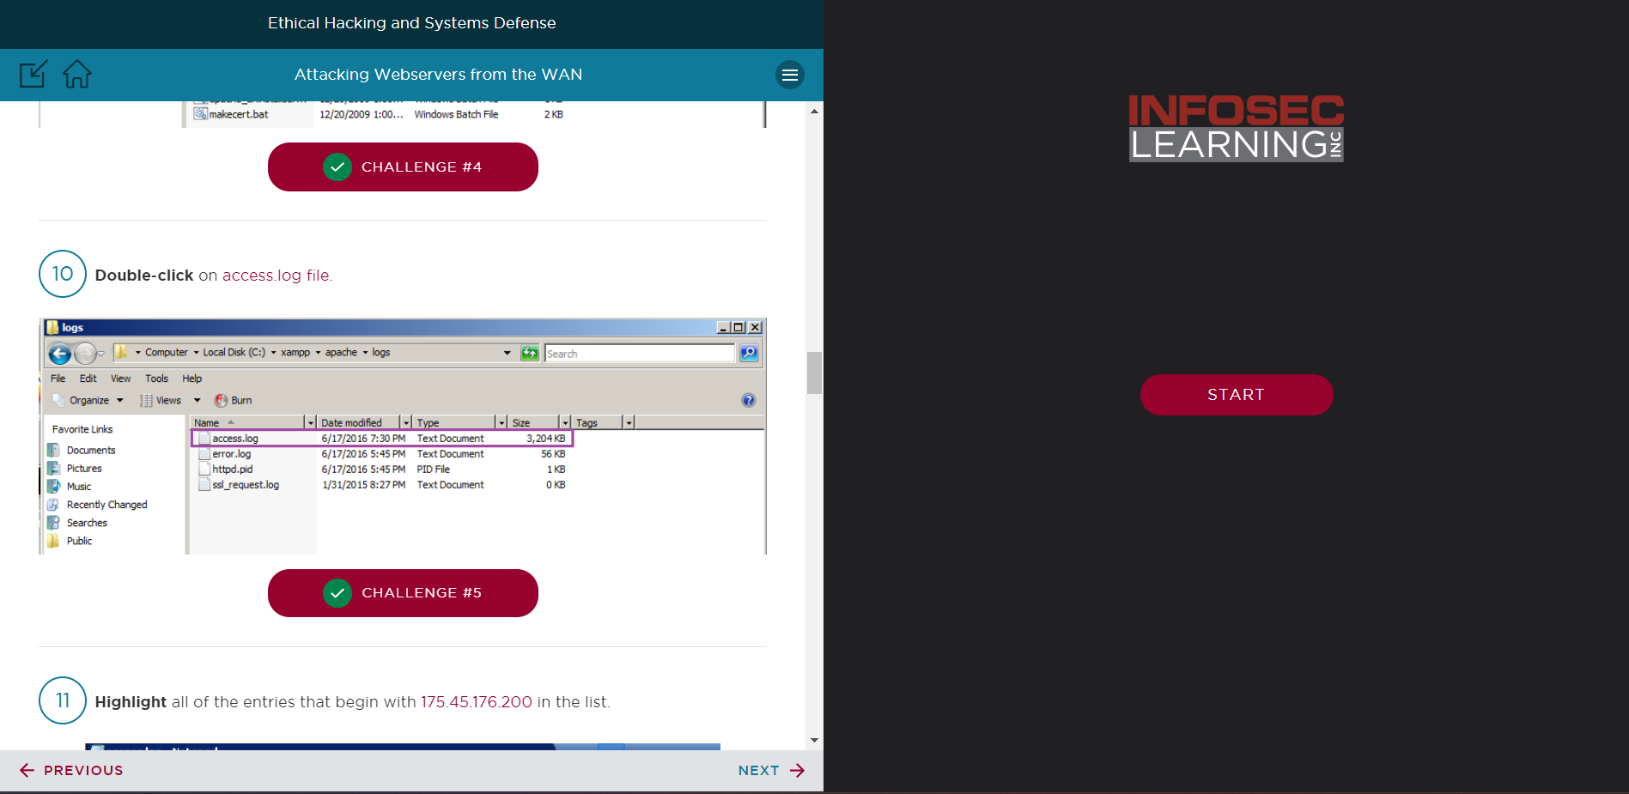

# Conclusion & Wrap-Up

## Summary with observations, Success & Failures, Challenges

**Observations:**

* The lab session showed how to use Kali Linux to attack a web server from a wide area network.
* Utilizing tools such as nmap, Bruter, and RDP, vulnerabilities were exploited at various stages.
* The attacker was able to mask their tracks and deface the website after gaining access.

**Success:**

* Using nmap/Zenmap, the attacker was able to map out the network and find active hosts and open ports.
* In roughly ten minutes, the bruter was able to successfully brute force the SMTP password.
* RDP used stolen credentials to grant remote access to the web server.
* Index.html was altered by vandals to deface the website.
* After deleting log entries, Apache was restarted to hide tracks.

**Challenges:**

* It required several attempts to find one of the challenge flags when scanning with Zenmap.
* It took a while for the password to be compromised by the Bruter brute force assault.
* After defacing the website, Apache has to be stopped and restarted in order for changes to load.
* Traces of the attack were manually and laboriously removed from the log files.

To sum up, the attacker was successful in taking advantage of weaknesses, obtaining unrestricted access, vandalizing the website, and hiding some of their footprints. But the attack needed time, a variety of tools, and laborious clearing up. The lab gave participants excellent practical experience in WAN-based web server attacks.

**Risks:**

* Web servers and apps that are open to exploitation are vulnerable. Attackers might then be able to switch to internal resources, steal data, or vandalize websites.
* Authentication flaws such as brute force susceptibility and weak passwords. This makes unapproved access possible.
* Ports and exposed services expand the attack surface. More opportunities translate into more vectors.
* Software and operating systems without patches. Numerous known vulnerabilities arise from this.
* Absence of log visibility or logging. interferes with incident reaction and detection.
* Inadequate access controls and permissions. causes resources to be accessed without authorization.
* Firewall rules or network segmentation are absent. Allows for lateral movement.

**Remediations:**

* Update software and harden web servers. Conduct a penetration test.
* Put MFA and a secure password policy into practice. thwart brute force assaults.
* Shut down any unused ports and services. Restrict access.
* Continue managing vulnerabilities and patches.
* Put in place centralized log analysis and logging systems.
* Utilize ACLs and the least privileged model. distinct roles.
* Use internal firewalls and network segmentation to prevent lateral movement.